**Course _____12 Methods_____ Year __12___**

Student name: ________________ Teacher name: ________________

**Task type: Response/Investigation**

**Time allowed for this task: ____40_______ mins**

**Number of questions: _____7______**

**Materials required:** No calculators nor classpads

Standard items: Pens (blue/black preferred), pencils (including coloured), sharpener, correction fluid/tape, eraser, ruler, highlighters

Special items: Drawing instruments, templates, notes on one unfolded sheet of   
A4 paper, and up to three calculators approved for use in the WACE examinations

**Marks available: ___40___ marks**

**Task weighting: _10___%**

**Formula sheet provided: Yes**

**Note: All part questions worth more than 2 marks require working to obtain full marks.**

Q1 (2, 3 & 3 = 8 marks) (3.1.7-3.1.8)

Determine  for each of the following.(No need to simplify)

1. 

|  |
| --- |
| **Solution** |
|  |
| **Specific behaviours** |
| 🗸 correct coefficient  🗸 correct power (no need for positive power) |

1. 

|  |
| --- |
| **Solution** |
|  |
| **Specific behaviours** |
| 🗸 uses product rule  🗸 one correct product  🗸 two correct products (no need to simplify) |

1. 

|  |
| --- |
| **Solution** |
|  |
| **Specific behaviours** |
| 🗸 uses quotient rule  🗸 correct denominator  🗸 correct numerator(no need to simplify) |

Q2 (2 & 3 = 5 marks) (3.1.8)

Consider  .

1. Determine 

|  |
| --- |
| **Solution** |
|  |
| **Specific behaviours** |
| 🗸 uses chain rule  🗸 evaluates derivative |

1. Determine the equation of the tangent at 

|  |
| --- |
| **Solution** |
|  |
| **Specific behaviours** |
| 🗸 solves for y value at x=0  🗸 solves for constant  🗸 states tangent equation |

Q3 (1, 1, 3 & 3 = 8 marks) (3.1.7-3.1.8, 3.1.15)

Consider the following functions .

|  |  |
| --- | --- |
|  |  |

1. Determine the derivative of  when 

|  |
| --- |
| **Solution** |
| Gradient = -1 |
| **Specific behaviours** |
| 🗸 states gradient |

1. Determine the derivative of  when 

|  |
| --- |
| **Solution** |
| Gradient = 6 |
| **Specific behaviours** |
| 🗸 states gradient |

1. Determine the derivative of  when .

|  |
| --- |
| **Solution** |
|  |
| **Specific behaviours** |
| 🗸 uses product rule  🗸 uses correct values for all variables  🗸 states final value |

1. Determine the derivative of  when .

|  |
| --- |
| **Solution** |
|  |
| **Specific behaviours** |
| 🗸 uses chain rule and is demonstrated  🗸 uses correct value for derivative of f  🗸 states final value |

Q4 (2, 3 & 2 = 7marks) (3.1.13 – 3.1.17)

The following is the graph of , the derivative of .

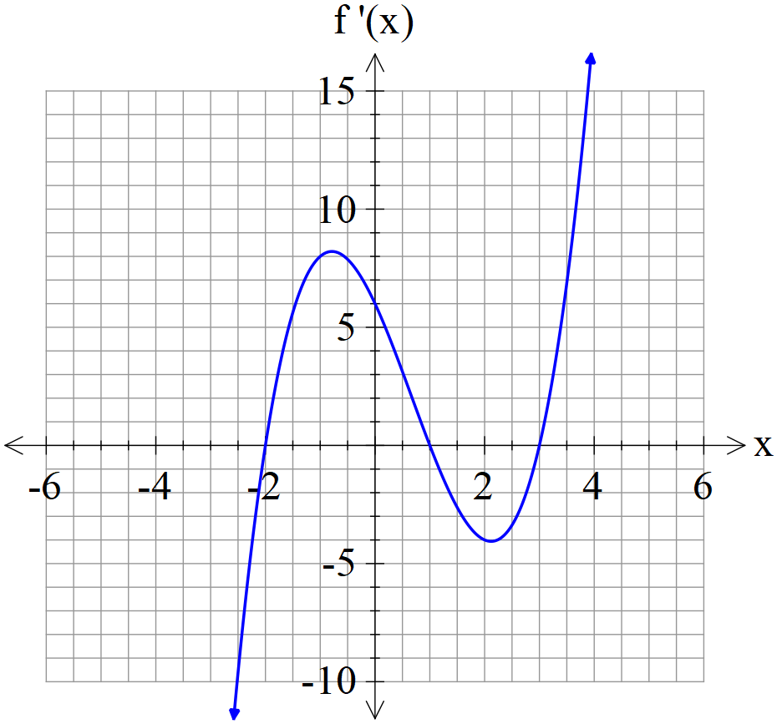

1. State the x values of all stationary points of .

|  |
| --- |
| **Solution** |
| -2, 1 & 3 |
| **Specific behaviours** |
| 🗸 states one correct x value  🗸 states all three values |

1. State the nature of each stationary point above and justify.

|  |
| --- |
| **Solution** |
| -2, local min as  1, local max as  3, local min as |
| **Specific behaviours** |
| 🗸 states nature of at least two stationary points  🗸 states reason using first or second derivatives for at least two pts  🗸 states nature and reason for all three stationary points |

1. State approximate x value for an infection point(s) and explain why.

|  |
| --- |
| **Solution** |
| Near -1 & 2 as |
| **Specific behaviours** |
| 🗸 states near x values  🗸 states reason using second derivative |

Q5 (3 & 2 = 5 marks) (3.1.12)

The displacement of a body from the origin O, at time  seconds, is  metres where



1. Determine the time(s) that the velocity is zero metres/second.

|  |
| --- |
| **Solution** |
|  |
| **Specific behaviours** |
| 🗸 differentiates  🗸 equates velocity to zero and factorises/quadratic formula  🗸 states both t values |

1. Determine when the acceleration is zero.

|  |
| --- |
| **Solution** |
|  |
| **Specific behaviours** |
| 🗸 differentiates velocity  🗸 solves for t value |

Q6 (3 marks) (3.1.10)

The period  of a swinging pendulum of length  is given by .

Using the increments formula, determine the approximate percentage change in if  changes by 3%

|  |
| --- |
| **Solution** |
|  |
| **Specific behaviours** |
| 🗸 uses increments formula  🗸 obtains expression for approx. change in T  🗸 obtains % change |

.Q7 (4 marks) (3.1.16)

Consider a cylindrical container that has an open end. The surface area of the container is . Determine the exact value of the radius of the closed end that maximises the volume. (Justify)

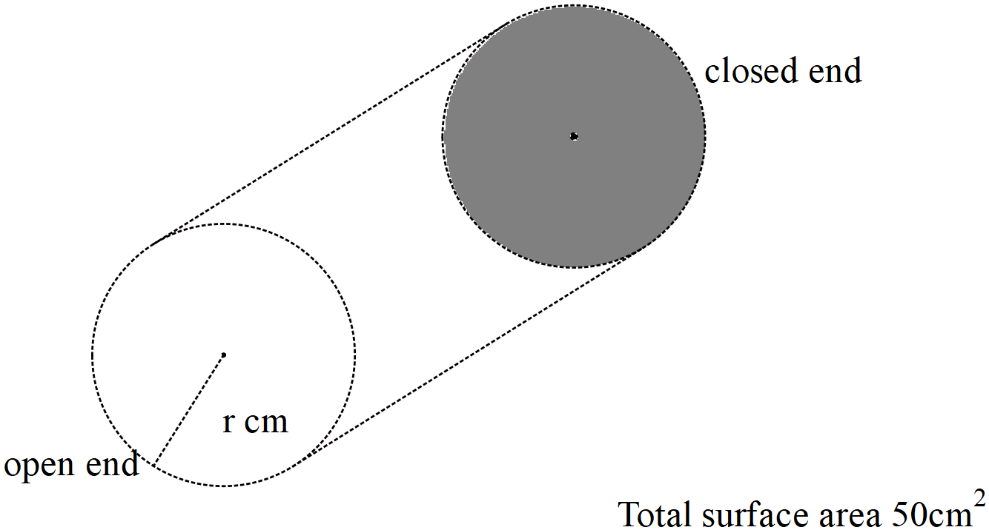

|  |
| --- |
| **Solution** |
|  |
| **Specific behaviours** |
| 🗸 obtains constraint equation containing h & r  🗸 obtains expression for V in terms of one variable only  🗸 obtains derivative and equates to zero  🗸 obtains optimal value and confirms with second derivative |